**Marketflash Campaigns DB Management System**

1. **Create Database ‘Marketflash’ in SQLite**

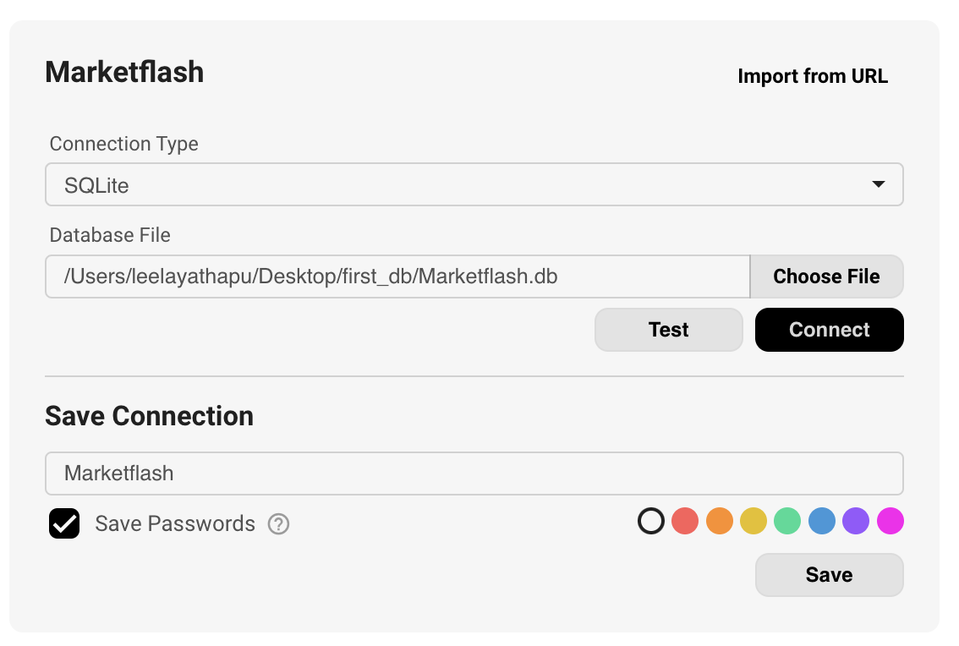

1. **Creating Entities based on functional ERD**

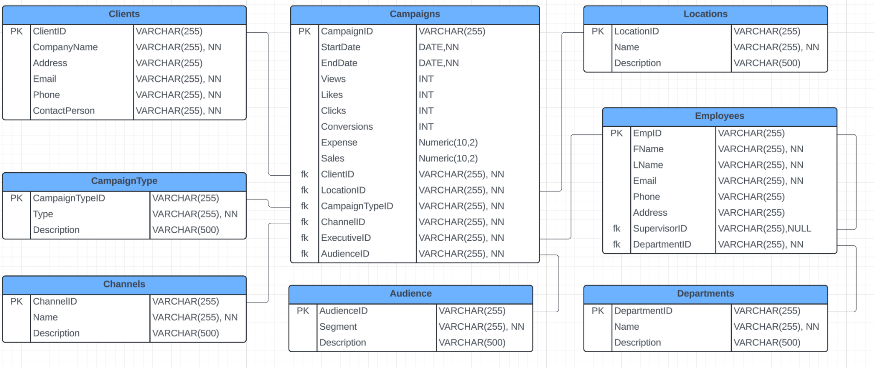

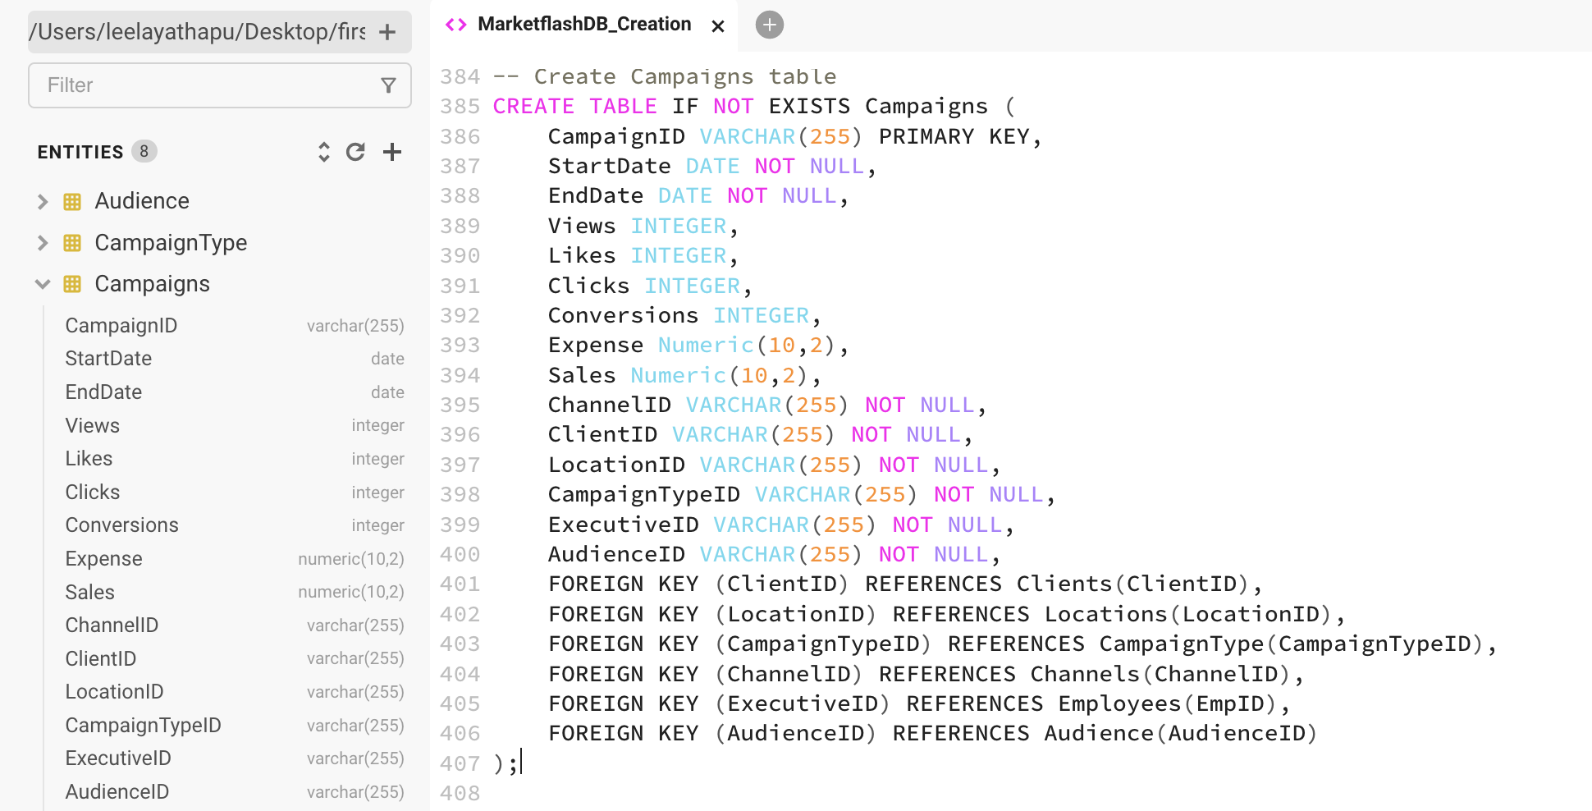

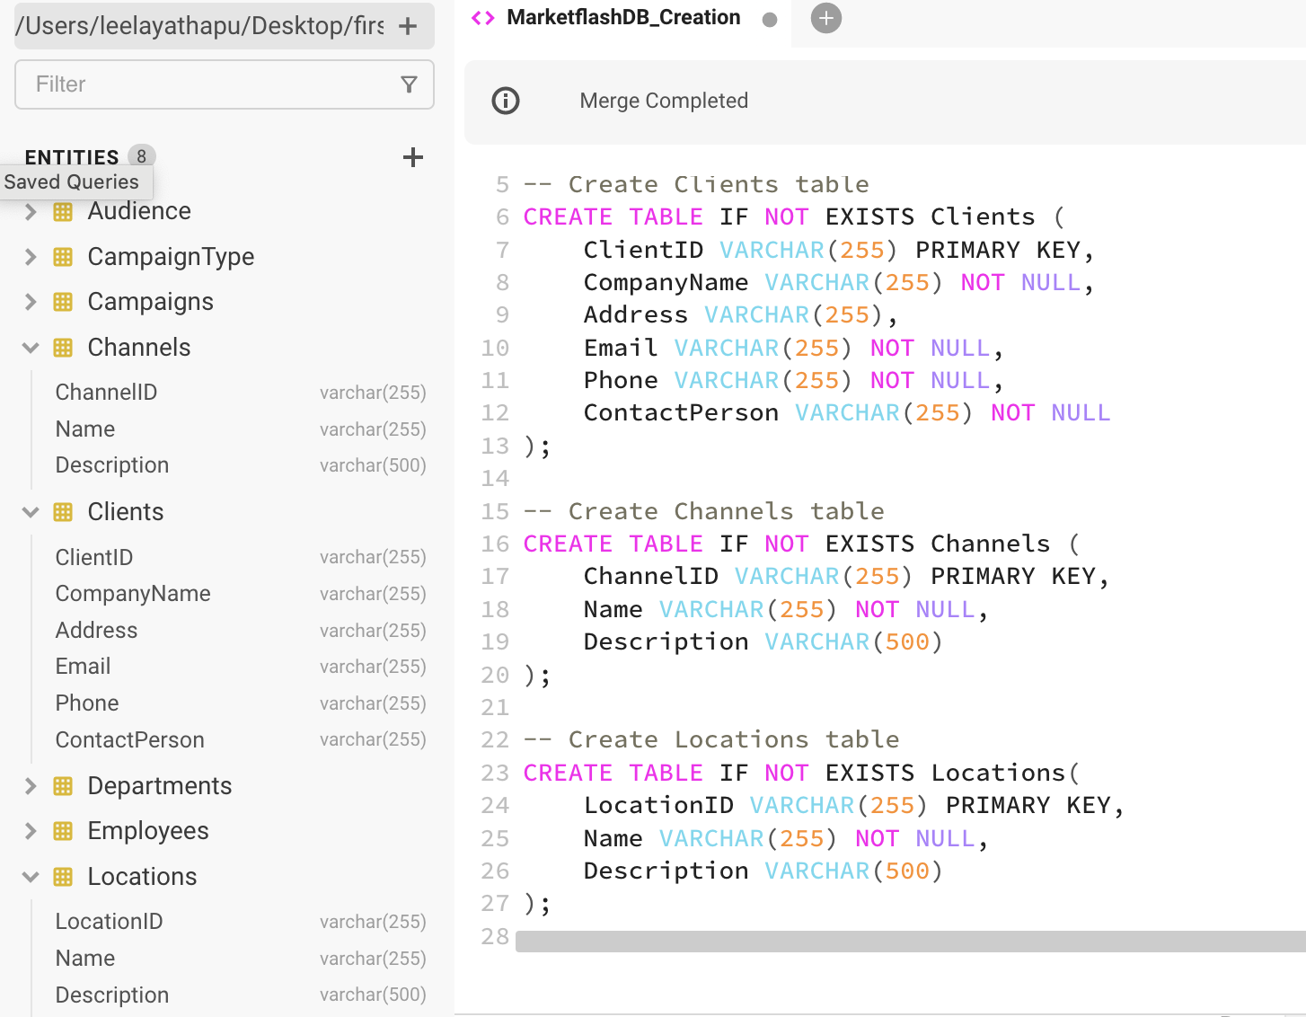

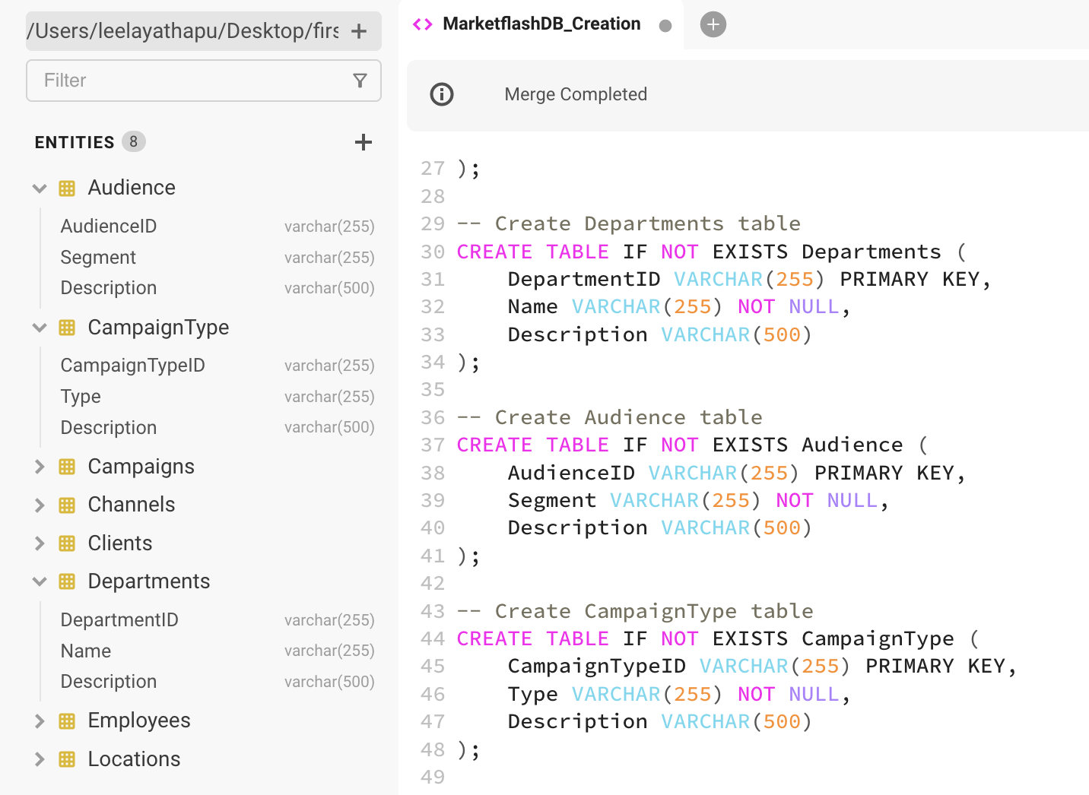

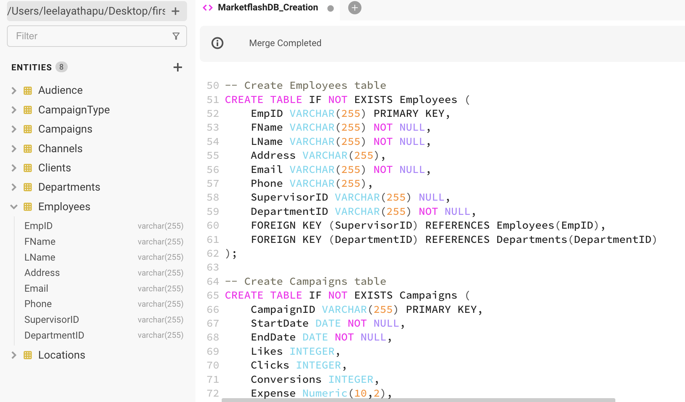

1. **Populate values into the ‘Marketflash.db’ tables (Click on image for video to play)**

[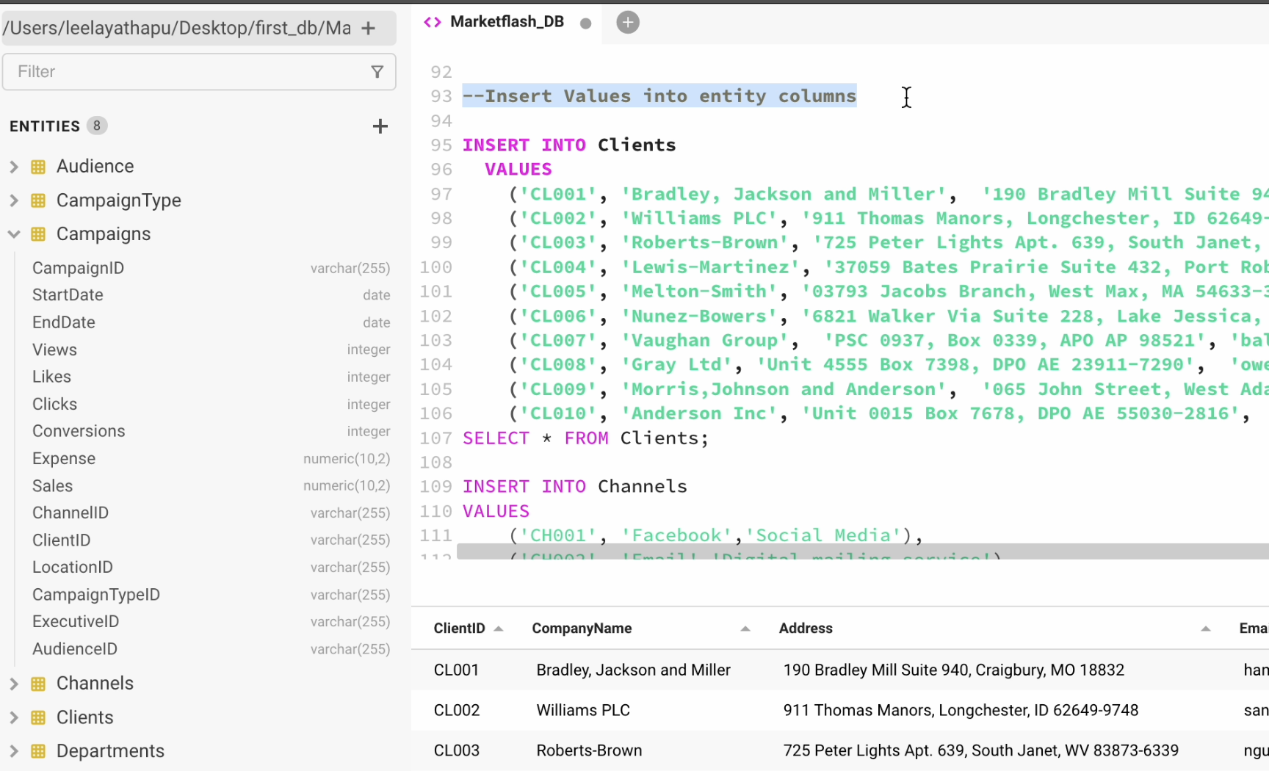](https://drive.google.com/file/d/1U3G5dfCsy1w3VtXSMMCtVz1A4tIi-0wA/view?usp=sharing)

**Link:** [**https://drive.google.com/file/d/1U3G5dfCsy1w3VtXSMMCtVz1A4tIi-0wA/view?usp=sharing**](https://drive.google.com/file/d/1U3G5dfCsy1w3VtXSMMCtVz1A4tIi-0wA/view?usp=sharing)

1. **Validating Design Using SQL commands**

1. SELECT

e.EmpID AS EmployeeID,

e.FName AS FirstName,

e.LName AS LastName,

e.SupervisorID,

s.FName AS SupervisorFirstName,

s.LName AS SupervisorLastName

FROM

Employees e

LEFT JOIN

Employees s ON e.SupervisorID = s.EmpID;

2.SELECT *

FROM Audience

JOIN Campaigns ON Campaigns.AudienceID=Audience.AudienceID;

3.SELECT *

From Channels

JOIN Campaigns ON Campaigns.ChannelID=Channels.ChannelID;

4.SELECT e.EmpID,e.FName,e.LName,d.Name

FROM Employees e

JOIN Departments d ON e.DepartmentID=d.DepartmentID;